**40.1 AOP Read Method Arguments with JoinPoints - Overview**

**Problem**:

* **When we are in an aspect (i.e. for logging)**
* **How can we access method parameters?**

**Development Process (Step-by-Step)**:

1. Access and display Method Signature
2. Access and display Method Arguments

**Step 1 - Access and display Method Signature**:

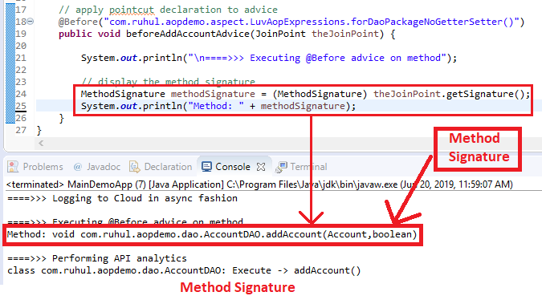

**Step 2 - Access and display Method Arguments**:

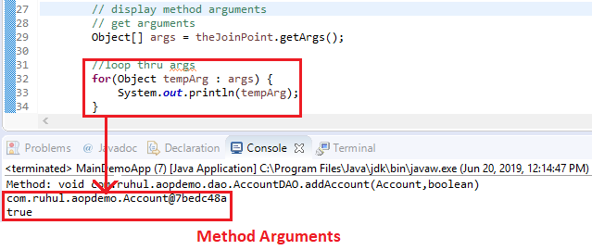

1. AOP Read Method Arguments with JoinPoints - Overview